Формируем читательскую грамотность учащихся.
Несплошные тексты
Рудякова Т.И. старший преподаватель кафедры филологии
Учебно-методическая разработка для учителей английского языка
«Читательская грамотность - способность к чтению и пониманию учебных текстов, умение извлекать информацию из текста, интерпретировать и использовать ее при решении учебных, учебно-практических задач и в повседневной жизни».
В исследованиях PIRLS - «способность понимать и использовать письменную речь во всем разнообразии ее форм для целей, определяемых обществом и/ или ценных для индивида».
В исследованиях PISA - «способность человека понимать и использовать письменные тексты, размышлять о них и заниматься чтением для того, чтобы достигать своих целей, расширять свои знания и возможности, участвовать в социальной жизни».
Для формирования у учащихся читательской грамотности следует использовать разные виды учебных текстов:
- сплошные тексты (описание, повествование, рассказы, стихи, сочинения);
- несплошные тексты (таблицы, графики, диаграммы, списки, карты, объявления…);
- смешанные тексты (сплошные + несплошные тексты);
- составные тексты (несколько текстов)

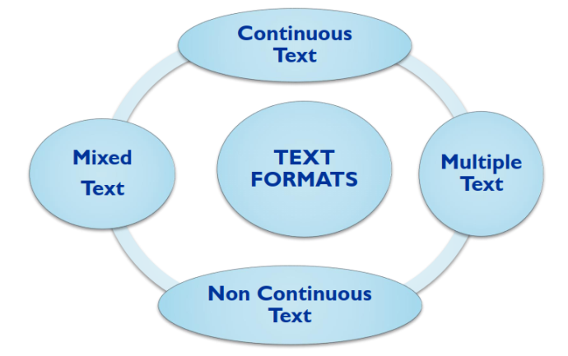
Мы предлагаем примеры несплошных текстов, c которыми учащиеся встречаются или могут встретиться в реальной жизни. К текстам разработаны упражнения. Материал может быть использован для формирования базовых читательских умений учащихся.

NON CONTINUOUS TEXTS
A LANGUAGE SCHOOL WEBSITE
You are looking for a language school online and you find the English Made Easy School (EME). You want to study an intensive general English course at Pre-Intermediate level in London. Read the webpage very quickly. Does this school offer the course you want in the place you want?

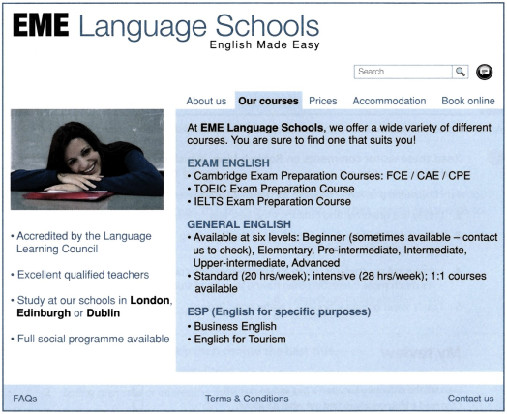

Answer the questions

- Do they do exam preparation course for IELTS?
- Do they run Advanced courses?
- Do they teach English for Law?
- Do they have a school in Manchester?
- Can you book online?
- Do they organize social activities?

AN ONLINE REGISTRATION FORM
- Read your friend’s registration form and answer the questions

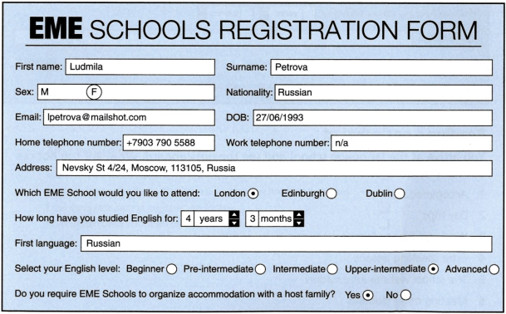
- Where is Ludmila from?
- When was she born?
- Where is she going to stay while in London?
- What is Ludmila’s level of English?
- How long has she been studying English?

- Complete the registration form with your own details
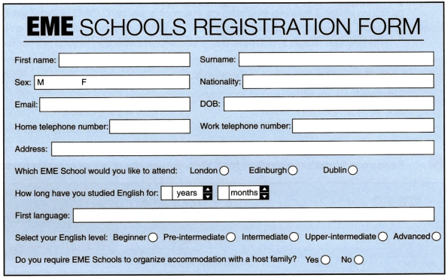
READING A NOTICEBOARD
You arrive at the language school and see the noticeboard. What are the notices about? Write a or
- Accommodation _____
- Day trips _____
- Weekend trips to Europe _____
- Extra speaking lessons _____
- The school website information _____
- Meeting other students _____

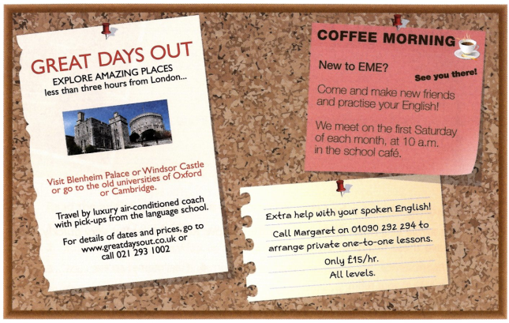
Read the notice again. Are the sentences true or false?
- Great Days Out organizes day trips to places within three hours of London.
- Great Days Out organizes trips by train.
- Margaret offers private lessons to students of all levels.
- Margaret’s lessons cost £15 for 30 minutes.
- The coffee morning happens every Saturday at 10am.
- The coffee morning takes place in the school café.

PICKPOCKET!
You are police officers who have found a stolen wallet in London’s Oxford Street. The wallet does not contain an address, or any money or credit cards. Find out as much as possible about its owner.

Contents of Wallet

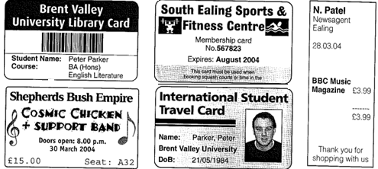

Metropolitan Police | Details of Victim |  | Crime Report Form
Surname: |  | First name:
Title: Mr/Mrs/Miss/Ms |  | Date of birth
Address: |  | Telephone number:
Occupation: |  | Nationality:
Interests and hobbies:

CHOOSING A MOBILE PHONE

You are going to buy a mobile phone. Read the leaflet very quickly and choose the right phone and service package.

Your needs are:

- Phone use: not very often (200-300 minutes a month);
- Text messages: a lot (about 150 messages a month);
- You do not use the phone abroad.

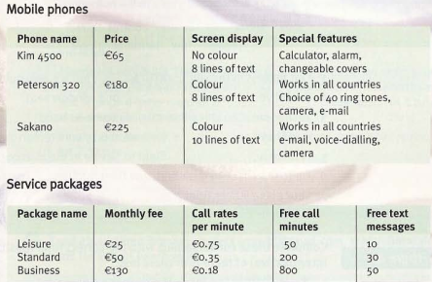

I’ve chosen ________________________

JOB ADVERTISEMENTS
You are looking for a full-time permanent job in sales in London. You want a supervisor’s role, which pays more than £25,000 every year. Scan through the list and find any suitable jobs

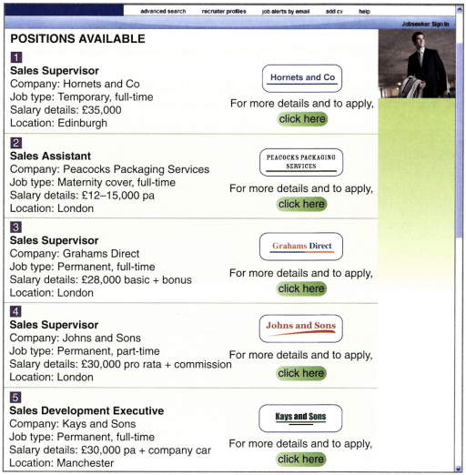

The suitable job(s) is (are) ____________________

Skillwise Delivery Services is looking for extra staff before Christmas. Scan the advert quickly and answer the questions

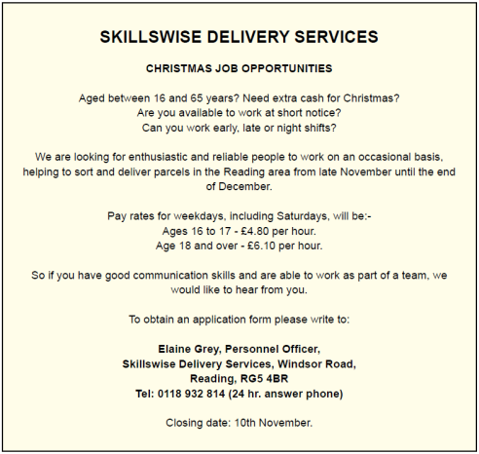

- When do these jobs start?
- The work will last for about a month, isn’t it?
- What type of work is on offer?
- What kind of people is Skillwise Services looking for?
- What shift patterns are available?
- Where is the job based?
- Does the work involve travels around the UK?
- How much will you earn per hour if you are aged 18?
- Will you be paid extra for working on Saturday?
- Whom should you contact at Skillwise Delivery Services to get an application form?
- Can you leave a message on an answering machine?
- Do you need to be able to work at short notice?
- It is 1st November. Is there still time to apply for a job?
- Is the minimum age for this job 18?
- Do you need a driving license to apply for a job with Skillwise Services?
PLANNING YOUR TRIP

You are planning a trip to New York and look online to find interesting places to visit. Read the website and answer the questions.

- How big is Central Park?
- What time does Central Park open?
- When was New York Public Library built?
- Which two areas of New York does Brooklyn Bridge link?
- How many people visit Times Square every year?
- Where exactly is Grand Central Station?

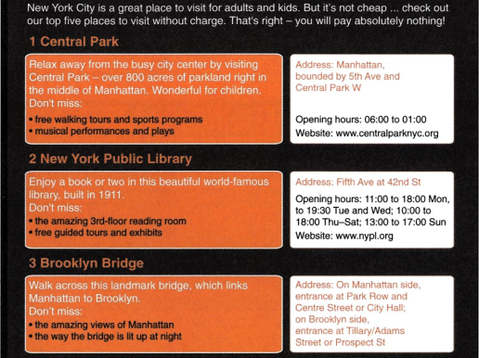
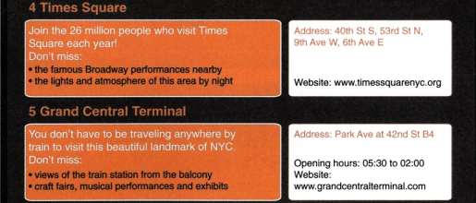

Which places might these people like to visit?
- I love books more than anything!
- I really like big open spaces.
- I love seeing shows and performances of any kind.
- I’m really interested in trains.
- I like sightseeing at night. Cities really come to life after dark!
- I enjoy looking at beautiful views!

VISITING A MUSEUM

You are going to visit the Portman Museum. Read the webpage of the museum and answer the questions.

Does this page give the following information?

- What there is to see at the museum.
- What times the museum is open.
- How to become a member.
- How much it costs.

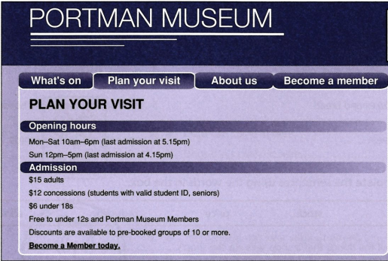

Underline the correct answer.
- The museum opens at 10am / 12pm / 6pm on Thursdays.
- Last admission on Sundays is 4.15pm / 5pm / 5.15pm.
- Admission for one senior, one teenager (aged 13) and one child (aged 6) is $18 / $21 / $27.
- Admission for two adult Portman members is free / $24 / $30.
- A group of four / eight / twelve people gets a discount.
BUYING SOMETHING IN A SHOP

While you are waiting to pay, another customer asks you some questions about the notice. Answer her questions.

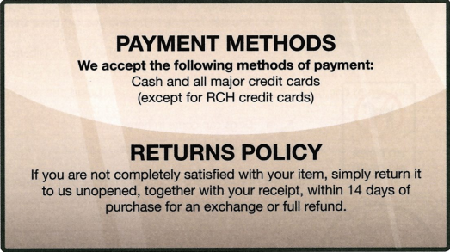

- Can I pay by RCH credit card?
- If my daughter doesn’t like it, can I bring it back and get my money back?
- I won’t be able to get back to the shop for three weeks. Will it be OK to bring it back then?
- Do I need to keep the receipt?
- Can I bring it back if it’s been opened?

You buy two items. One costs £2.99 and the other is £10. You pay with a £20 note. Read the receipt and circle the mistake.

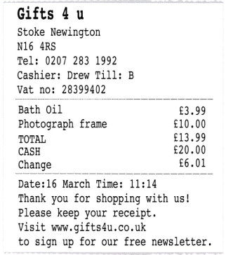

Answer her questions.
- What’s the name of the shop?
- What’s the name of the cashier who sold you the things?
- What was the date and time that you bought the presents?
- What’s the last date that you can return the items and get your money back?
- What can you sign up for at the gift shop website?
CHOOSING A FILM

You want to go to the cinema so you read some films reviews to decide which film to see. Read the reviews and answer the questions.

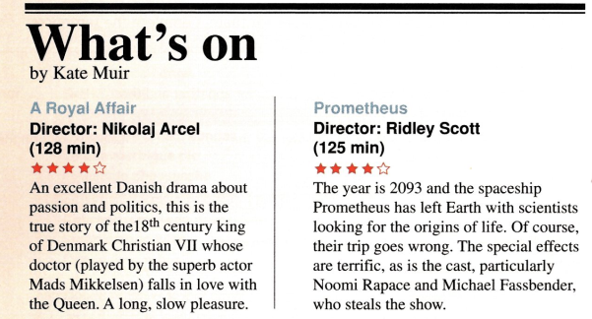

- Which film is based on something that really happened?
- Which actor plays the doctor in ‘A Royal Affair’?
- What year is it in ‘Prometheus’?
- Where does ‘Prometheus’ take place?
- Which actor does the writer like best in ‘Prometheus’?

DECIDING WHERE TO EAT

You are in San Francisco. You look at some restaurant review online. Read the reviews and suggest a restaurant or restaurants to these people.

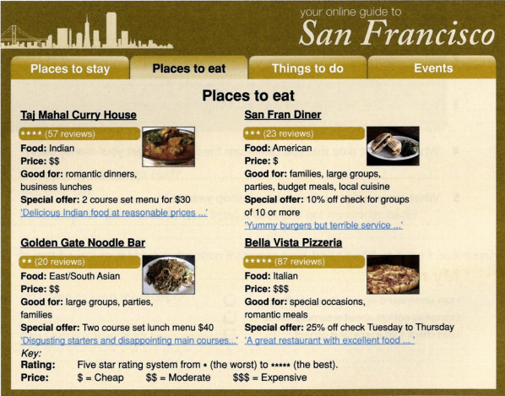

- I want to go to the place with the highest star rating.
- We don’t have much money and are travelling on a very small budget.
- I’m eating out with my kids.
- I’m planning a romantic meal with my wife.
- I love pizza – Italian food is my favourite!
- I always like to taste the local food of the place I’m staying. Here is San Francisco. That means I’m looking for a great burger!

GOING TO THE PHARMACY

Your son has earache so you go to the pharmacy to buy him some medicine. Read the leaflet from inside the medicine box. Are the sentences true or false?

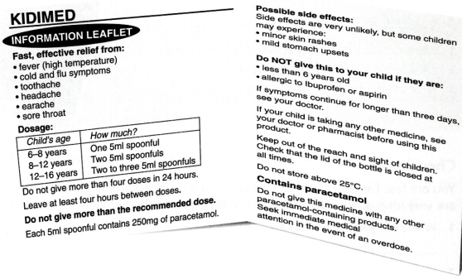

- My son is ten years old, so he should take 5ml spoonfuls of medicine.
- It’s 4pm. He can have one dose now and another at 8pm.
- Then I can give him doses every four hours, which means medicine at 12am, 4am, 8am, 12pm and 4pm over the next 24 hours.
- My son might get a rash or a stomach upset after taking the medicine.
- If he still has earache tomorrow, I should take him to the doctor.
- My daughter is two years old. If she has earache, I can give her this medicine.

AT AN AIRPORT. GOING THROUGH SECURITY

You are going to fly to Canada. Read the notice.
Your friend wants to check that he has understood the notice correctly. Are his statements true or false? Correct any that is false.

- I must take off my coat and put it on the conveyor belt.
- I must keep my shoes on.
- I must empty my pockets, put my things in a tray and put the tray on the conveyor belt.
- I can take my 90ml bottle of shampoo in a clear, re-sealable plastic box.
- I can take my 1litre bottle of water in a clear, re-sealable plastic box.
- I may be able take my 150ml bottle of medicine in a clear, re-sealable plastic box.

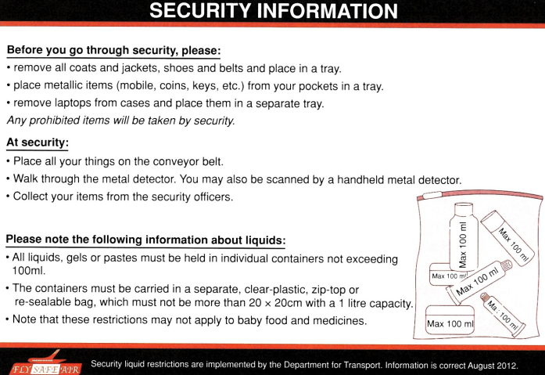

BOARDING THE PLANE

It’s nearly time for your plane to leave. Check your boarding pass and answer the questions.

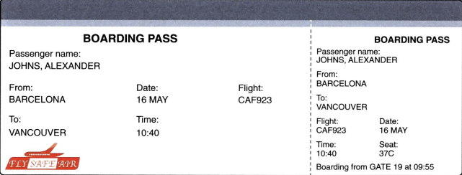

- What’s my flight number?
- What gate do I need to go to?
- What time do I need to get to the gate?
- What’s my seat number?

CHECKING TRAIN INFORMATION ONLINE

You want to travel from London to Birmingham, so you check the train information online. Read the website answer the questions.

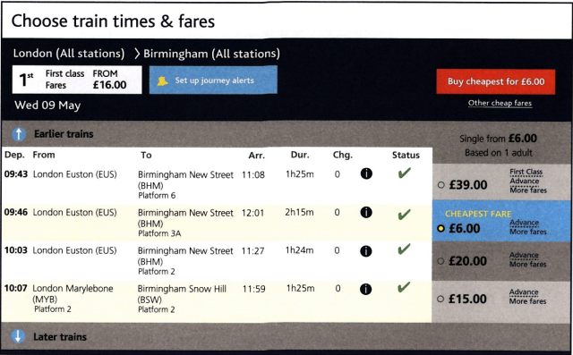

- How much is the cheapest ticket to Birmingham?
- What time does this train leave and what time does it arrive?
- What London station does it leave from and what Birmingham station does it go to?
- Do you have to change trains?
- Which is the fastest train to Birmingham and how much does it cost?

READING ABOUT A HOTEL

You arrive at a hotel and see the leaflet below. Read the leaflet very quickly. Does it have these facilities?

- Room service ……….
- A safe in your room ……….
- Film rental ……….
- Free Internet access ……….
- Jacuzzi ……….
- Swimming pool ……….

Choose the correct answer

- You can/can’t get a drink from the minibar in your room.
- You can/can’t eat breakfast on Sunday at 09:45.
- You can/can’t have lunch on Thursday at 14:00.
- You can/can’t leave your bags in the left-luggage room.
- You can/can’t do sports in the gym at 06:30.

